|  |  |  |
| --- | --- | --- |
| CREST 06 | **Carlingford High School**  **Mathematics Extension 2**  **HIGHER SCHOOL CERTIFICATE**  **TRIAL EXAMINATION TERM 3 2019** | |
| **Student Number:** _____________________________________ | | |
| * **General Instructions** * Reading time – 5 minutes * Working time – 3 hours * Write using black or blue pen   Black pen is preferred   * Board-approved calculators may be used * A Reference & MC Sheet is provided at the back of this paper * In Questions 11 – 16, show relevant mathematical reasoning and/or calculations | | **Total Marks – 100**  **Section I**  Pages 3 – 6  **10 marks**   * Attempt Questions 1 – 10 * Allow about 15 minutes for this section   **Section II**  Pages 7 – 15  **90 marks**   * Attempt Questions 11 – 16 * Allow about 2 hours and 45 minutes for this section |

|  |  |  |  |  |  |  |  |  |
| --- | --- | --- | --- | --- | --- | --- | --- | --- |
|  | **MC** | **Q11** | **Q12** | **Q13** | **Q14** | **Q15** | **Q16** | **Mark** |
| **Complex Numbers** | **/2** | **/8** |  |  | **/3** |  |  | **/13** |
| **Graphs** | /1//1//  **/2** |  |  | **/7** |  |  |  | **/9** |
| **Conics** | **/1** |  |  | **/8** |  | **/2** |  | **/11** |
| **Polynomials** | **/1** | **/3** |  |  | **/3** | **/6** |  | **/13** |
| **Integration** | **/1** | **/4** | **/8** |  | **/4** |  |  | **/17** |
| **Volumes** | **/1** |  | **/4** |  | **/3** |  |  | **/8** |
| **Mechanics** | **/1** |  |  |  |  | **/7** | **/12** | **/20** |
| **Harder 3U** | **/1** |  | **/3** |  | **/2** |  | **/3** | **/9** |
| **Total** | **/10** | **/15** | **/15** | **/15** | **/15** | **/15** | **/15** | **/100** |

|  |  |
| --- | --- |
| **Section I**  **10 marks**  **Attempt Questions 1 – 10.**  **Allow about 15 minutes for this section.** | |
| Use the multiple-choice answer sheet for Questions 1 – 10. | |
| 1. A | A hyperbola has directrices with equation $x = ±\frac{4\sqrt{21}}{7}$ and foci with coordinates $\left(±\sqrt{21} , 0\right).$ What is the eccentricity of the hyperbola?  (A) $\frac{2\sqrt{7}}{7}$ (B) $\frac{\sqrt{7}}{2}$ (C) $\frac{7}{4}$ (D) $\sqrt{21}$ |
|  | Find the gradient of the normal to the curve $x^{2}y^{3} + 3y - 4x =10 at the point (1, 2)$.  (A) $-\frac{4}{5}$ (B) $-\frac{3}{4}$ (C) $\frac{3}{4}$ (D) $\frac{5}{4}$ |
|  | Find the square root of −16 − 30*i*.  (A) $±\left(5 + 3i\right)$ (B) $±\left(5 3i\right)$ (C) $±\left(3 + 5i\right)$ (D) $±\left(3 5i\right)$ |
|  | Find $\int{\frac{dx}{x^{2} + 4x + 9}}$ *.*  (A) $\frac{1}{\sqrt{5}} \tan^{-1}\left(\frac{x + 2}{\sqrt{5}}\right) + c$ (B) $\frac{1}{5} \tan^{-1}\left(\frac{x + 2}{\sqrt{5}}\right) + c$ (C) $\frac{1}{\sqrt{5}} \tan^{-1}\left(\frac{x}{\sqrt{5}}\right) + c$ (D) $\frac{1}{5} \tan^{-1}\left(\frac{x}{\sqrt{5}}\right) + c$ |
|  | The area enclosed by the curve $y = e^{x^{2}}$ and the lines *x* = 1 and *y =* 1, is rotated about the *y*-axis.  What is the volume of the solid formed?  (A) $e - 2π$ (B) $e - 2$ (C) $eπ - 2π$ (D) $eπ – 2$ |
|  | A 1200-kilogram car moving at 20 m/s makes a turn around a circular roundabout with radius of 30 metres.  What is the net force acting upon the car?  (A) 13 $\frac{1}{3}$ N  (B) 800 N  (C) 12 000 N  (D) 16 000 N |

|  |  |
| --- | --- |
|  | The equation $P(x) = 3x^{3} - 4x^{2} + 2x - 7$ has roots $α, β and γ.$ Which equation has roots $α+ 2, β + 2 and γ + 2 ?$ (A) $3x^{3}- 22x^{2} + 54x - 51 = 0$ (B) $3x^{3}- 10x^{2} + 30x - 51 = 0$ (C) $3x^{3}- 8x^{2} + 8x - 56 = 0$ (D) $24x^{3}- 16x^{2} + 4x - 7 = 0$ |
|  | An archer finds that on average he hits the bullseye four times out of five.  If he fires four arrows, what is the probability that he will miss the bullseye at least 3 times?  (A) 0⋅0016  (B) 0⋅0272  (C) 0⋅512  (D) 0⋅8192 |
|  | In an Argand diagram, the point *A* represents the complex number *z*, the point *C* represents the complex number $ω$ and the point *B* represents the complex number *z + $ω$. O* is the origin.  What shape best describes the quadrilateral *OABC* ?  (A) Parallelogram  (B) Rectangle  (C) Rhombus  (D) Square |
|  | The graph of $y=f\left(x\right)$ is drawn below.  A picture containing indoor, photo  Description automatically generated  Which graph shows   1. (B)      1. A picture containing object, indoor     Description automatically generated (D) |

|  |
| --- |
| **Section II**  **90 marks**  **Attempt Questions 11 – 16.**  **Allow about 2 hours and 45 minutes for this section.** |
| Answer each question in a SEPARATE writing booklet. Extra writing booklets are available.  In Questions 11 – 16, your responses should include relevant mathematical reasoning and/or calculations. |

|  |  |  |
| --- | --- | --- |
| **Question 11** (15 marks) Use a new writing booklet. | |  |
| (a) | *Z* is the complex number .   1. Find *Z* in the form *x* + *iy*. | **2** |
|  | (ii) Find . | **1** |
|  | (iii) Find Arg (*Z*). | **1** |
|  | (iv) Find $Z^{4}$. | **1** |
| (b) | Factorise the polynomial $P(x) = x^{4} - 9x^{3} + 17x^{2} + 49x - 58$ fully over the complex field, given that: $P(5 - 2i) = 0.$ | **3** |
| (c) | Express $\frac{x}{\left(x + 1\right)\left(x^{2} + 1\right)} in the form \frac{A}{x + 1} +\frac{Bx + C }{x^{2} + 1}$ $and hence evaluate \int{\frac{x}{\left(x + 1\right)\left(x^{2} + 1\right)} dx}.$ | **4** |
| (d) | Sketch the region defined by $\frac{π}{4} ≤ Arg (z) ≤\frac{π}{3}$ and . | **3** |
|  | **End of Question 11** |  |

|  |  |  |
| --- | --- | --- |
| **Question 12** (15 marks) Use a new writing booklet. | |  |
| (a) | (i) Find $\int{\frac{dx}{9x^{2} + 6x + 5}}$. | **2** |
|  | (ii) Find $\int{\frac{5x - 3}{x^{2} + 6x+ 14} dx}$. | **3** |
|  | (iii) Evaluate $\int_{1}^{2}{x^{3} ln x dx}$. | **3** |
| (b) | Use logarithms and implicit differentiation to find the derivative of $y = x^{x + 1}$. | **3** |
| (c) | (i) Draw a neat sketch of the graph of $y = sin x + 2.$ | **1** |
|  | (ii) The area enclosed by the curve and the line *y* = 2, between *x* = 0 and *x* = π is rotated about the *x* – axis.  Calculate the volume of the solid of revolution formed. | **3** |
|  | **End of Question 12** |  |

|  |  |  |
| --- | --- | --- |
| **Question 13** (15 marks) Use the Question 13 writing booklet. | |  |
| (a) | The graph of $y=f\left(x\right)$ is shown below      Sketch the following curves on separate half page diagrams. |  |
|  | (i) | **1** |
|  | (ii) $y= \frac{1}{f\left(x\right)}$ | **2** |
|  | (iii) $y^{2}=f(x)$ | **2** |
|  | (iv) $y = ln[f(x)]$ | **2** |
|  | **Question 13 continues on page 10** |  |

|  |  |  |
| --- | --- | --- |
|  | **Question 13 continued** |  |
| (b) | The ellipse *E* has equation $\frac{x^{2}}{16} + \frac{y^{2}}{25} = 1$. |  |
|  | (i) Find the eccentricity of the ellipse. Use this to find the coordinate of the foci *S’* and *S,* as well as the equations of the directrices. | **3** |
|  | (ii) Show that the point *P* (4sin θ, 5cos θ) lies on the ellipse. | **1** |
|  | (iii) Prove that *PS + PS’* is independent of the position of *P* on the ellipse. | **2** |
|  | (iv) Find the equation of the normal to the ellipse at the point *P*. | **2** |
|  | **End of Question 13** |  |

|  |  |  |
| --- | --- | --- |
| **Question 14** (15 marks) Use a new writing booklet. | |  |
| (a) | Find the value of *b* in the polynomial equation $x^{3} + 3x^{2} - bx - 8 = 0$ if the roots of  the equation are in a geometric sequence. | **3** |
| (b) |  *A* solid has the region bounded by the circle $x^{2}+y^{2} = 4$ as its base $.$ The cross section of the solid, taken perpendicular to the *x*–axis, is an isosceles triangle with one of the equal sides lying in the base of the solid and an angle of 30o between the equal sides, as shown.  Find the volume of the solid*.* | **3** |
| (c) | (i) Derive the reduction formula : $I_{n}=\int{x^{n}e^{-2x}dx = -\frac{x^{n}e^{-2x}}{2}} + \frac{n}{2}I_{n - 1}$ | **2** |
|  | (ii) Hence evaluate $\int_{0}^{1}{x^{2}e^{-2x}dx}$ | **2** |
| (d) | (i) Use De Moivre’s Theorem to express $cos 4θ$ and $sin 4θ$ in terms of powers of $sin θ$ and $cos θ$. | **2** |
|  | (ii) Write an expression for $tan 4θ$ in terms of *t*, where *t* = $tan θ$. | **1** |
| (e) | For two positive real numbers *a* and *b,* prove that theirarithmetic mean $\frac{a + b}{2}$ is always  greater than or equal to their geometric mean $\sqrt{ab}$. | **2** |
|  | **End of Question 14** |  |

|  |  |  |
| --- | --- | --- |
| **Question 15** (15 marks) Use a new writing booklet. | |  |
| (a) | A particle *P* of mass 3*kg*, is attached by a light inelastic string to a fixed-point *A* as shown  in the diagram below. Another string of equal length attaches *P* to a smooth ring *Q,* of mass  4kg which is free to slide on a vertical wire that passes through *A*. The particle *P* is rotating  in a horizontal circle of radius *r*, about the vertical wire with a constant velocity of 3π  radians per second. Both strings are 1 metre in length.  A  1m  *h*  *r* P    1m  Q  Let $T_{1}$ represent the tension in the string *AP*, $T_{2} the tension in the string$*PQ* and *θ* the  angle of inclination of *AP* to the vertical wire. |  |
|  | (i) Copy the diagram into your answer booklet and clearly indicate on your sketch all the forces acting on *P* and *Q*. | **1** |
|  | (ii) Write down the equations expressing the vertical and horizontal equilibrium of forces at the points *P* and *Q*. | **3** |
|  | (iii) By using the equations in part (ii), evaluate $tan θ$ in terms of *r*. Hence calculate the vertical distance *h* of *P* below *A.*  (Use *g =* 9⋅8 m/ $s^{2}$) | **3** |
|  | **Question 15 continues on page 13** |  |

|  |  |  |
| --- | --- | --- |
|  | **Question 15 continued** |  |
| (b) | The parabola $y = 4 - x^{2}$ and the hyperbola $xy = 1$ intersect at the points *A, B* and *C* where $x = α, x = β and x = γ repectively.$ |  |
|  | (i) Show that $α, β and γ$ are the roots of the equation $x^{3} - 4x + 1 = 0.$ | **1** |
|  | (ii) Find the polynomial equation which has roots $α^{2}, β^{2} and γ^{2}$. | **2** |
|  | (iii) Find the numerical value of ${OA}^{2 }+ {OB}^{2} + {OC}^{2}$, given that *O* is the origin. | **3** |
| (c) | Prove that the line $y = mx + b$ will touch the rectangular hyperbola $xy = c^{2}$ if $b^{2}= -4mc^{2}$ | **2** |
|  | **End of Question 15** |  |

|  |  |  |
| --- | --- | --- |
| **Question 16** (15 marks) Use a new writing booklet. | |  |
| (a) | (i) A particle of mass *m* travels with a constant speed *v* m/s in a horizontal circle of radius *r*, around a track banked at an angle of  to the horizontal.  Show that, if there is no tendency for the particle to slip sideways, then | **2** |
|  | (ii) A vehicle is travelling around a circular curve of radius 500 metres. The distance between the wheels of the vehicle is 2 metres. When travelling at 72 km/h, there is no tendency for the vehicle to slide. Using *g* = 10 m/s2*.*  At what angle is the road inclined to the horizontal, correct to the nearest degree? | **2** |
|  | (iii) What is the distance of the outer wheels above the inner wheels?  (Give answer correct to the nearest cm) | **1** |
| (b) | A particle of mass *m* moves along the *x*-axis, beginning at *x* = 0.  It experiences a resistive force *R* given by *R = kv*, where *k* is a constant and *v* is the velocity of the particle. |  |
|  | (i) Show that its speed *v*, is given by $v = v_{0}e^{-\frac{kt}{m}}$, where $v_{0}$ is the initial speed. | **3** |
|  | (ii) Show that the displacement (*x*) of the particle after *t* seconds is given by $x = \frac{mv_{0}}{k}\left[1 - e^{-\frac{kt}{m}}\right]$ . | **3** |
|  | (iii) Show that its limiting position $x_{L}$ is given by *x $= \frac{mv_{0}}{k}$* . | **1** |
|  | **Question 16 continues on page 15** |  |

|  |  |  |
| --- | --- | --- |
|  | **Question 16 continued** |  |
| (c) | *ABC* is an equilateral triangle inscribed in a circle. *P* is a point on the minor arc *BC*.  Prove that $PA = PB + PC$. | **3** |
|  | **End of Paper** |  |

Carlingford High School

**2019**

TRIAL

HIGHER SCHOOL CERTIFICATE

EXAMINATION

REFERENCE SHEET

- Mathematics –

- Mathematics Extension 1–

- Mathematics Extension 2-

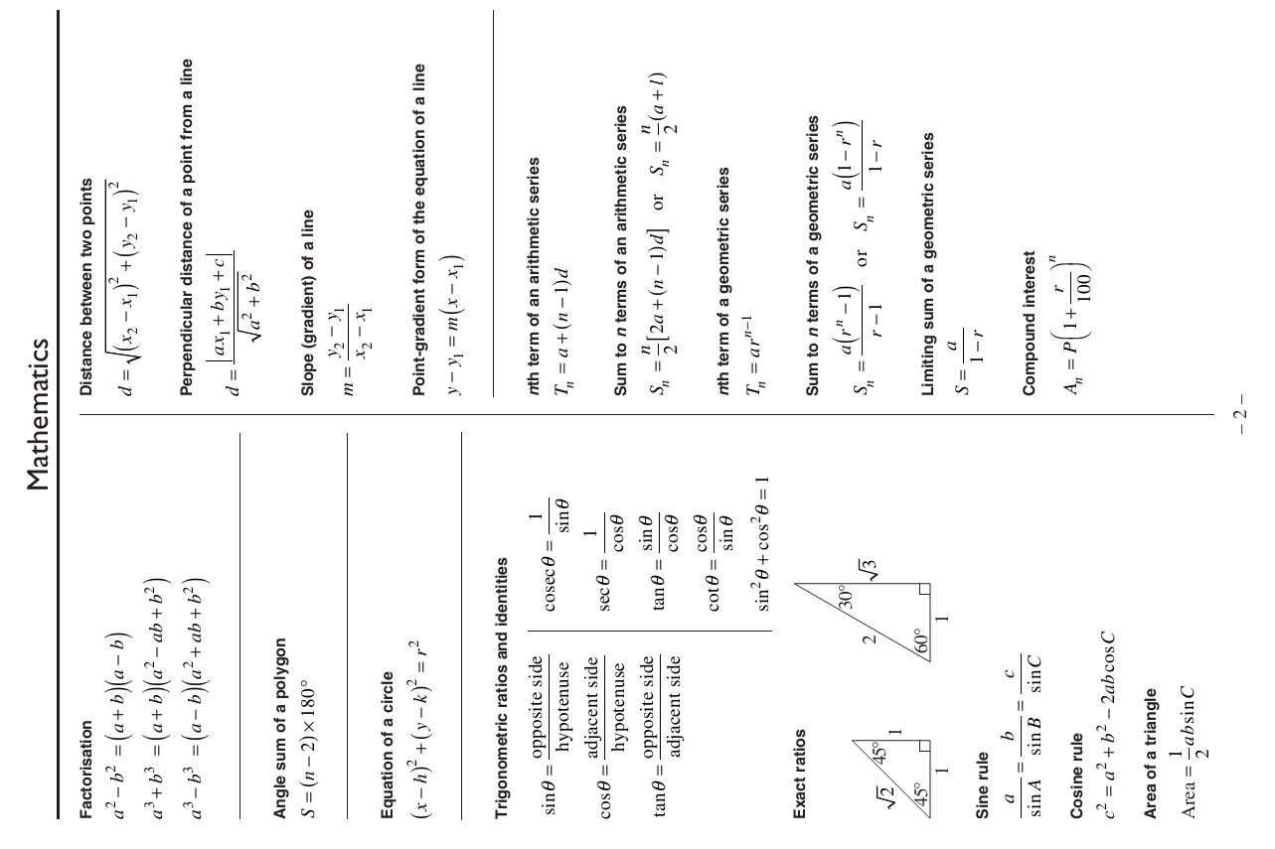

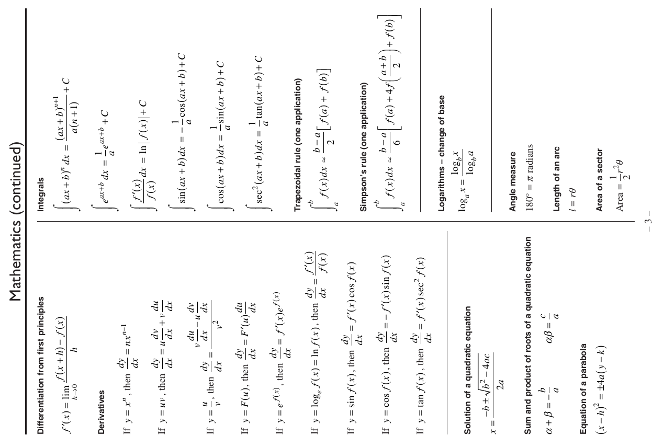

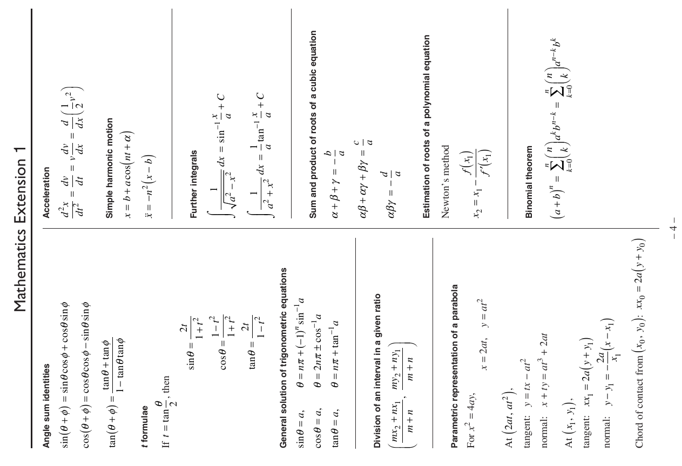

T**rial HSC Examination 2019**

**Mathematics Extension 2 Course**

Student Number ________________________________ Teacher ________________________

**Section I** – **Multiple Choice Answer Sheet**

**Allow about 15 minutes for this section**

Select the alternative A, B, C or D that best answers the question. Fill in the response oval completely.

|  |  |  |  |  |  |
| --- | --- | --- | --- | --- | --- |
| **Sample:** | 2 + 4 = | (A) 2 | (B) 6 | (C) 8 | (D) 9 |
|  |  |  |  |  |  |
|  |  | A oval2 | B oval-fill | C oval2 | D oval2 |

If you think you have made a mistake, put a cross through the incorrect answer and fill in the new answer.

|  |  |  |  |  |  |
| --- | --- | --- | --- | --- | --- |
|  |  | A oval-fill | B oval-cross | C oval2 | D oval2 |

If you change your mind and have crossed out what you consider to be the correct answer, then indicate the correct answer by writing the word **correct** and drawing an arrow as follows.

|  |  |  |  |  |  |
| --- | --- | --- | --- | --- | --- |
|  |  | A oval-cross | B oval-correct | C oval2 | D oval2 |

1. A B C D

2. A B C D

3. A B C D

4. A B C D

5. A B C D

6. A B C D

7. A B C D

8. A B C D

9. A B C D

10. A B C D